**Lab-1: Implementing Encryption Across Multiple Operating Systems**

**CSC-7303 - 11811 - Network Defense - 202501 – 001**

**Name: Unnati Patel – A00327586**

**Submitted to: Prof.  Maryam Ahmed**

**Part 1: Windows 11 Encryption  
BitLocker and BitLocker To Go**

**1. Enabling BitLocker:**

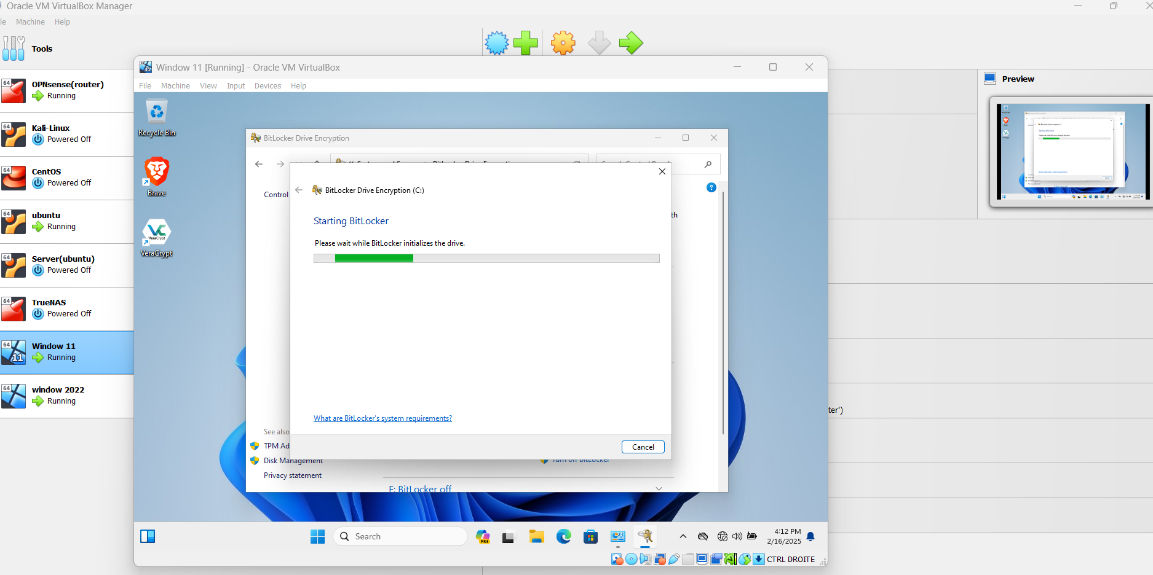

**Choose a method to unlock your drive at startup (password or USB key).**

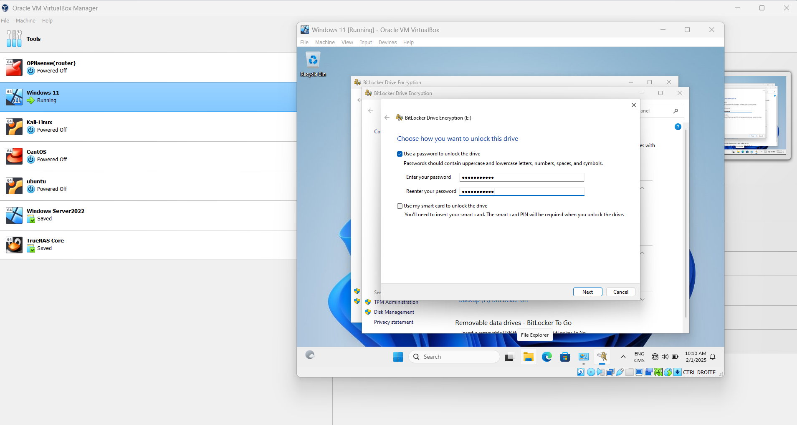

**Save the recovery key to a secure location (USB, file, or print it).**

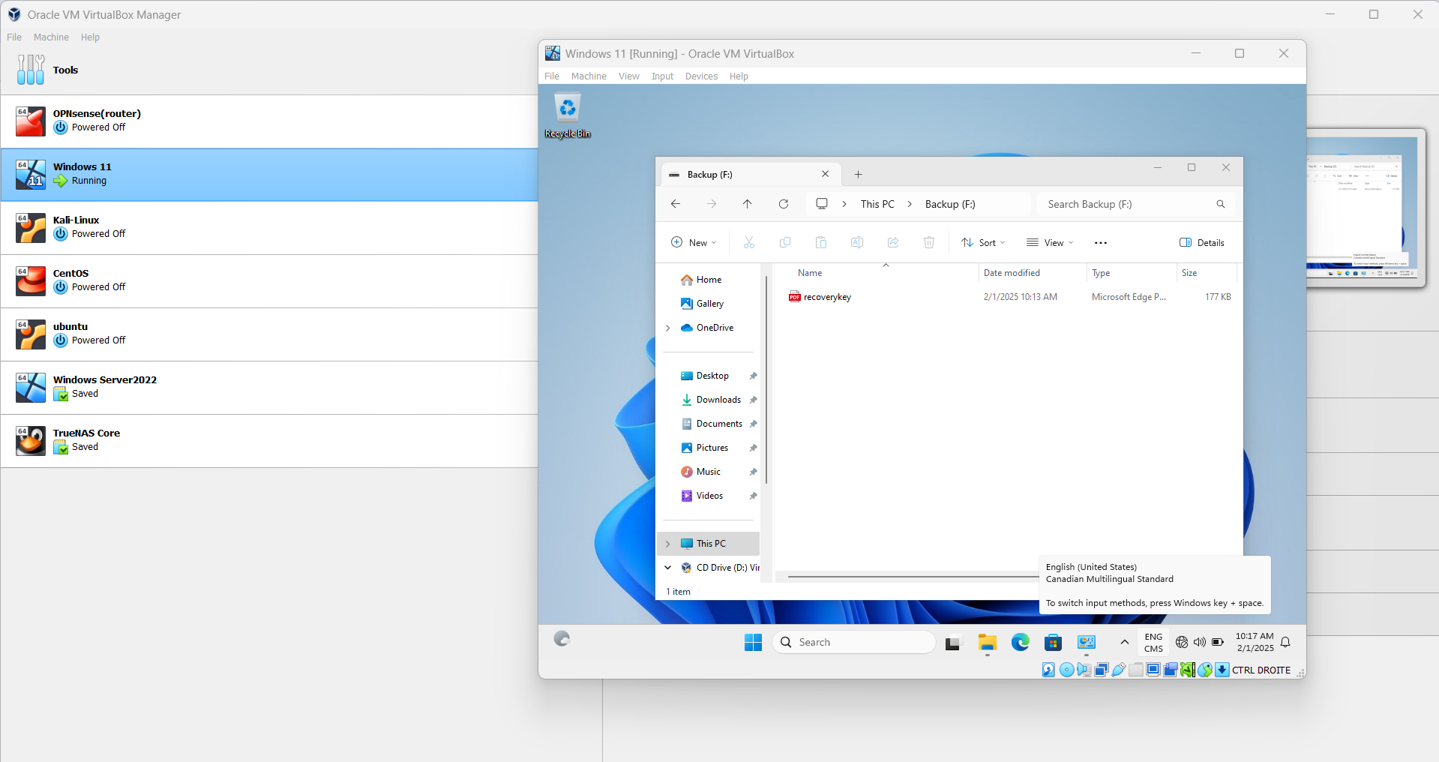

**Choose encryption options (used disk space only or entire drive).**

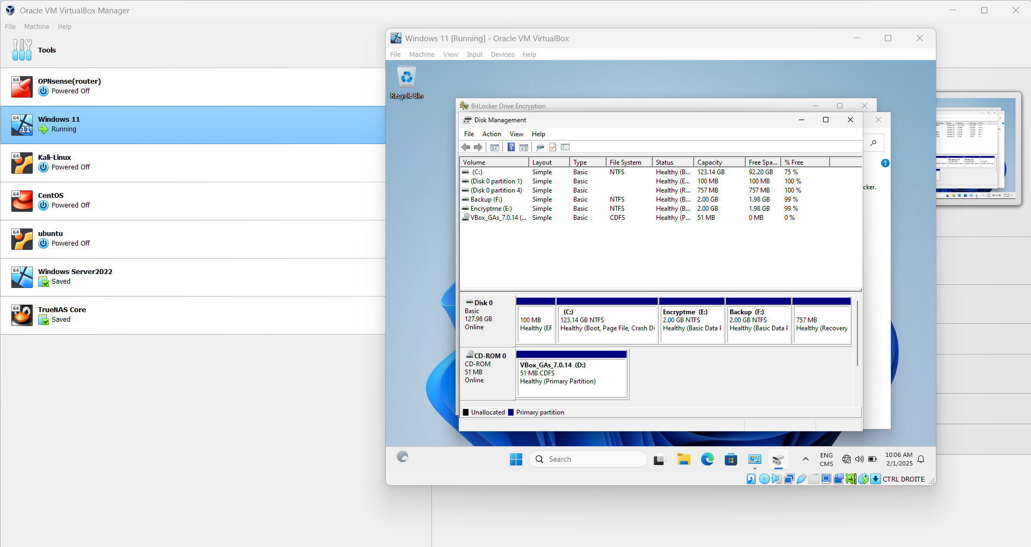

**Start the encryption process.**

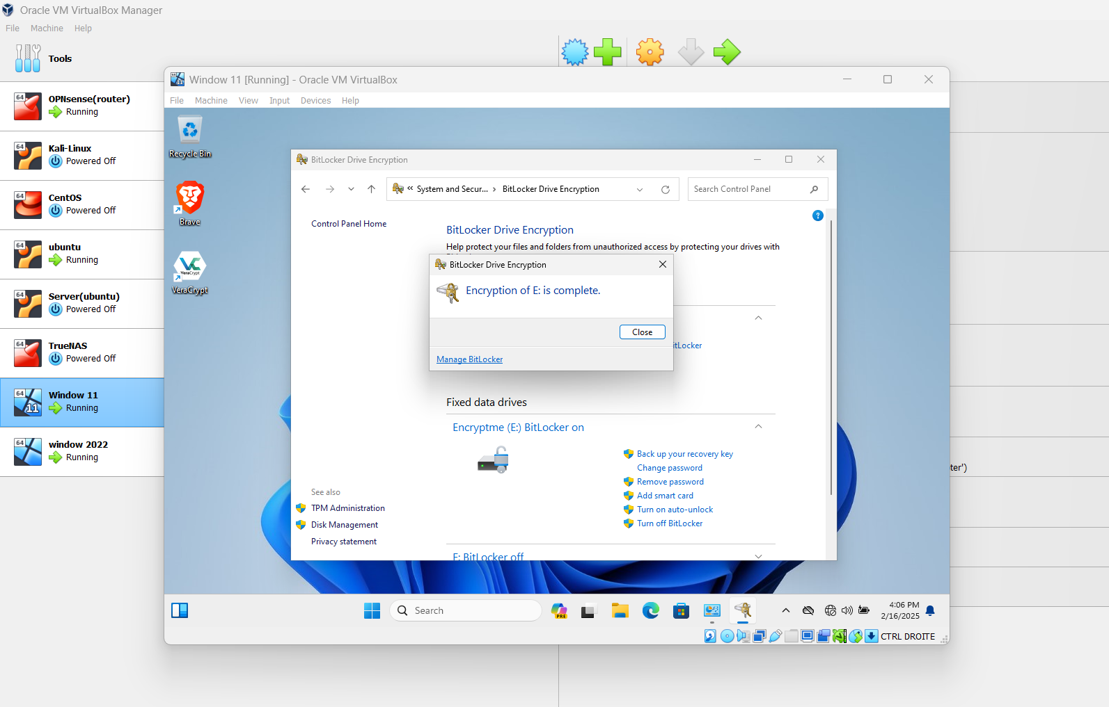

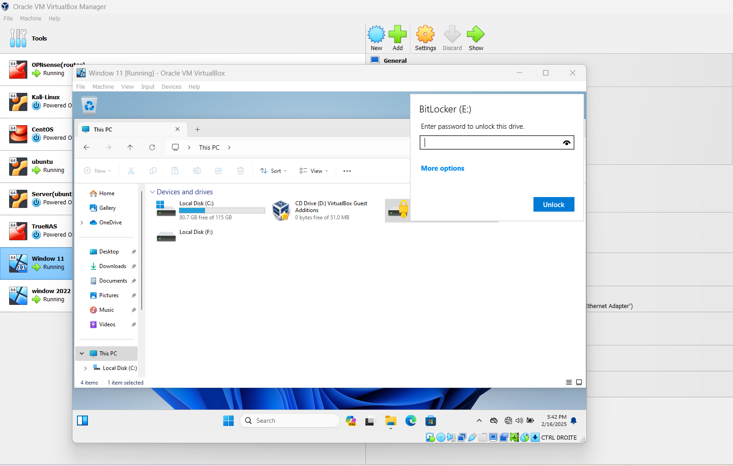

**VeraCrypt**

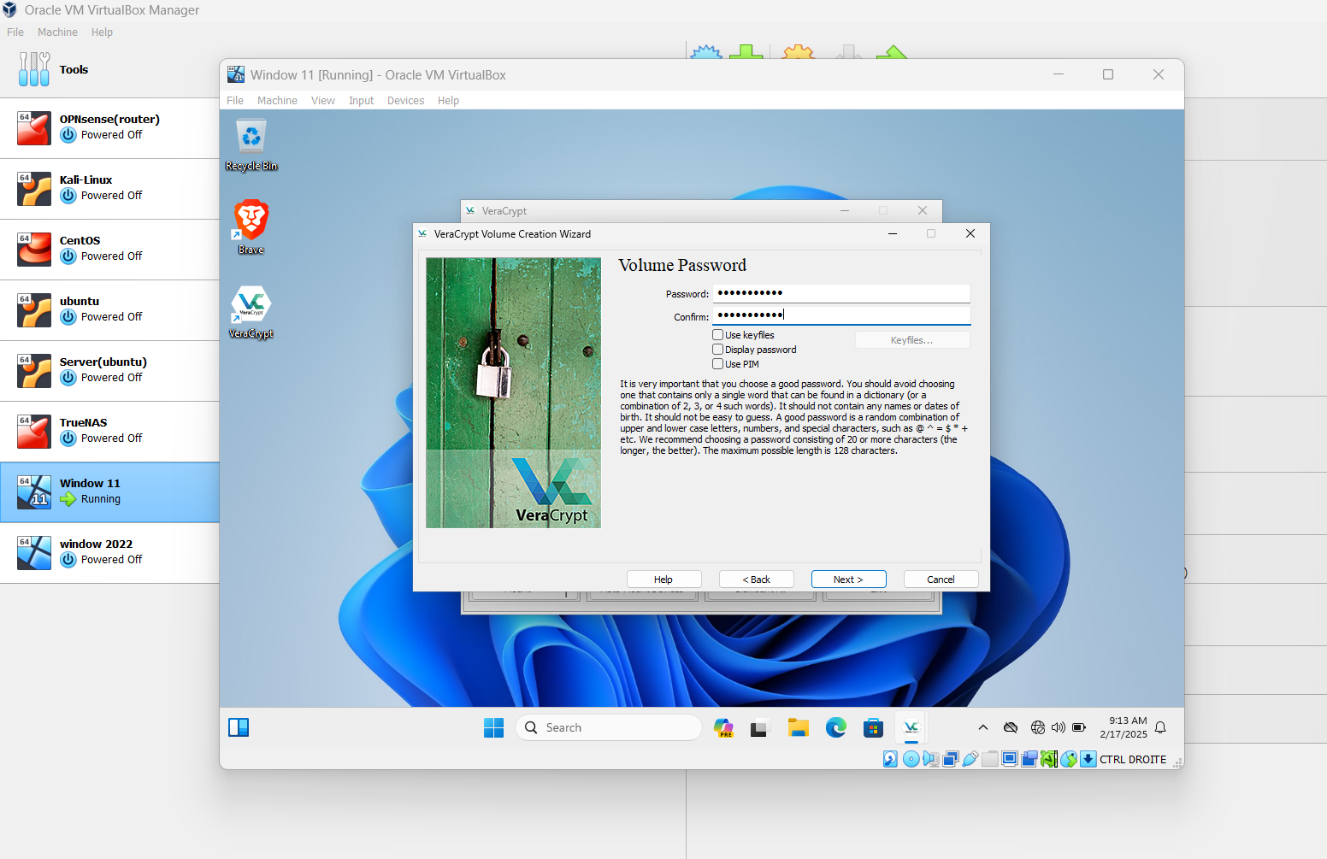

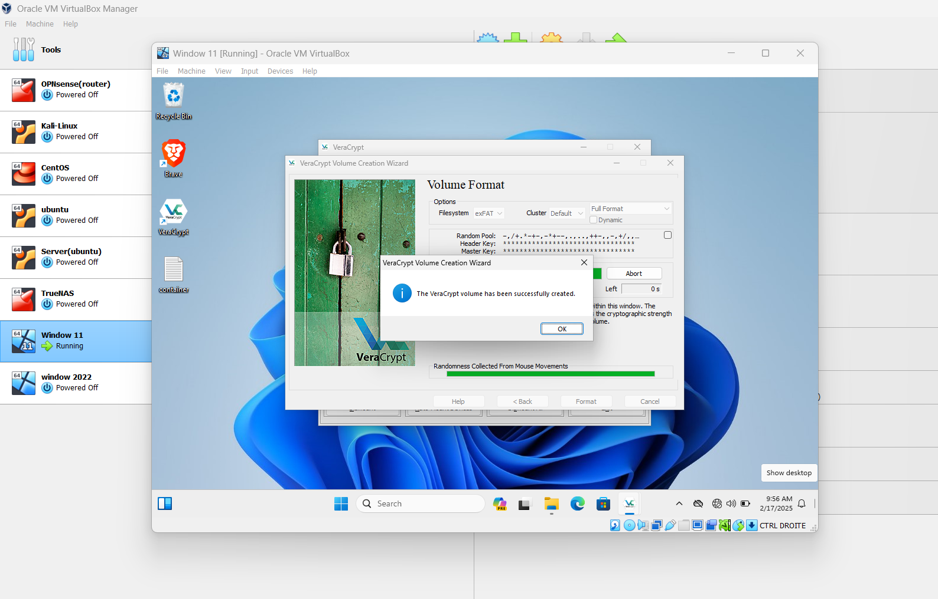

**Creating a VeraCrypt Volume:**

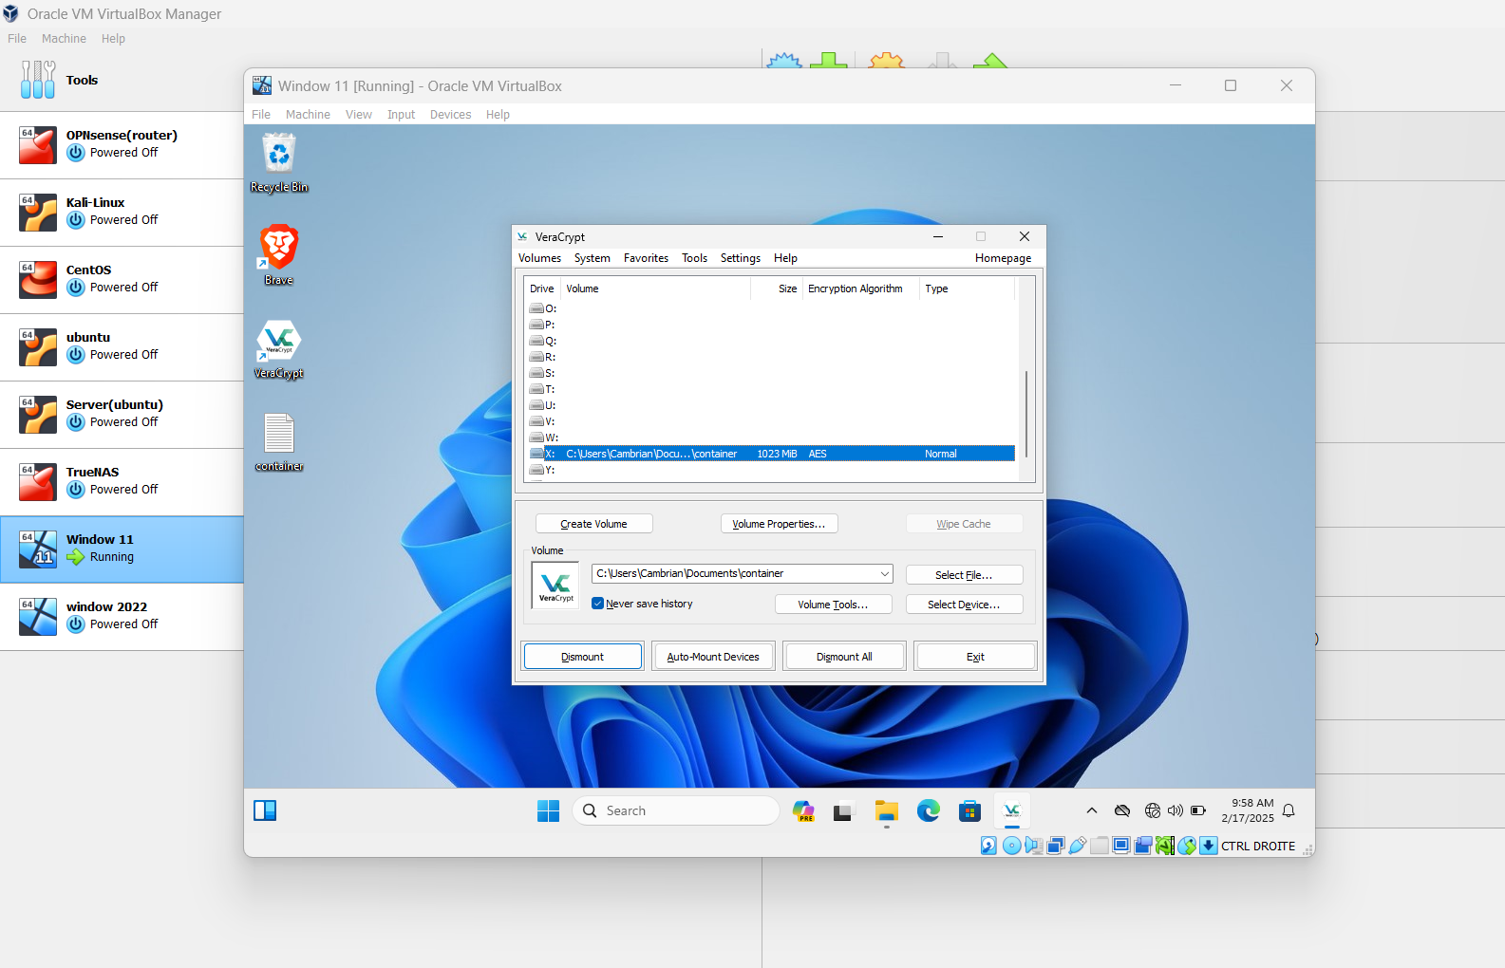

**Encrypting File System (EFS)**

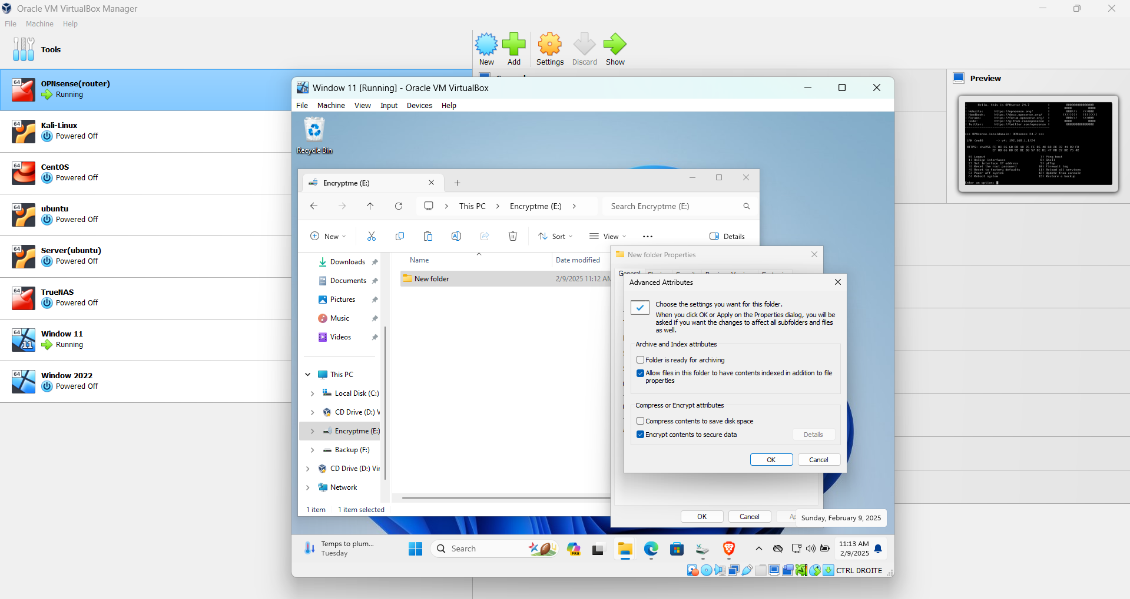

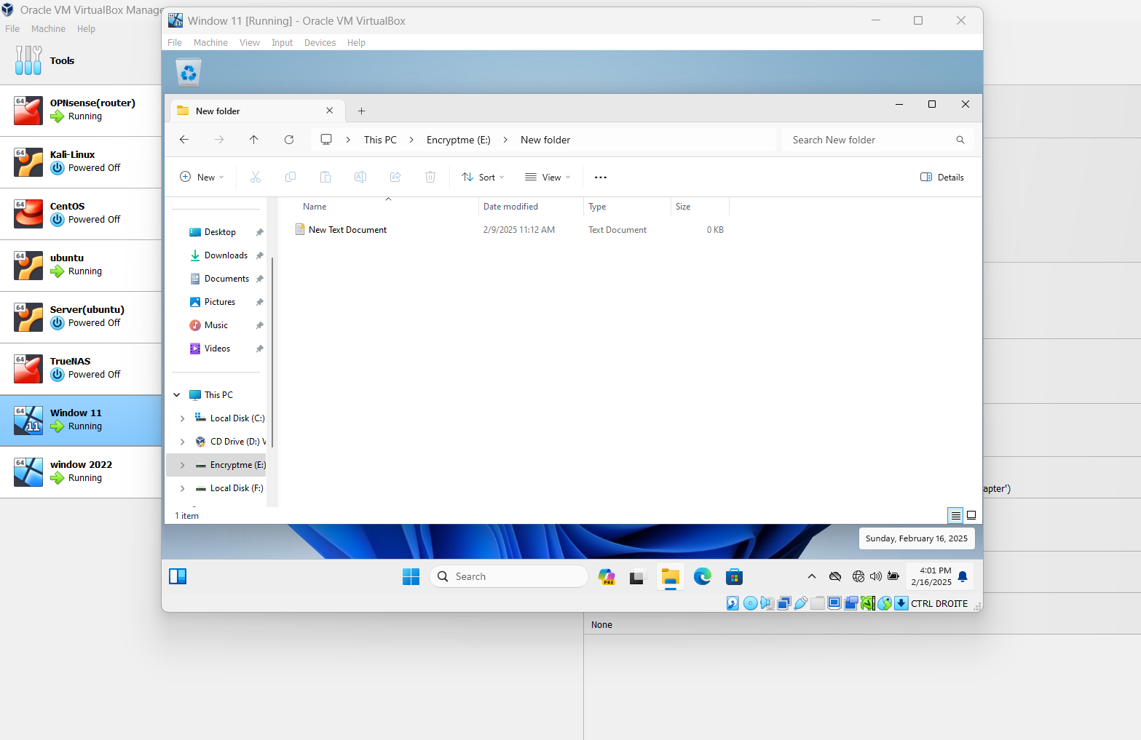

**Managing EFS Certificates:**

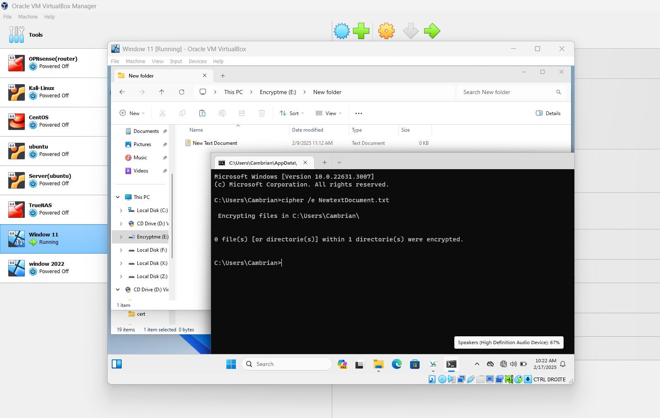

**PowerShell & CMD Encryption**

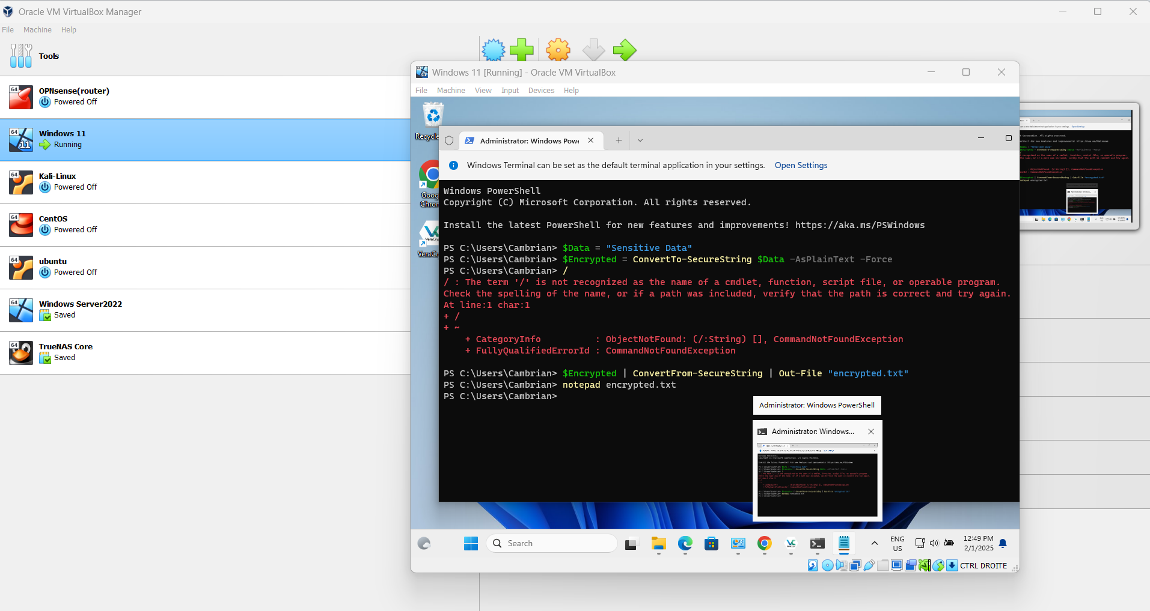

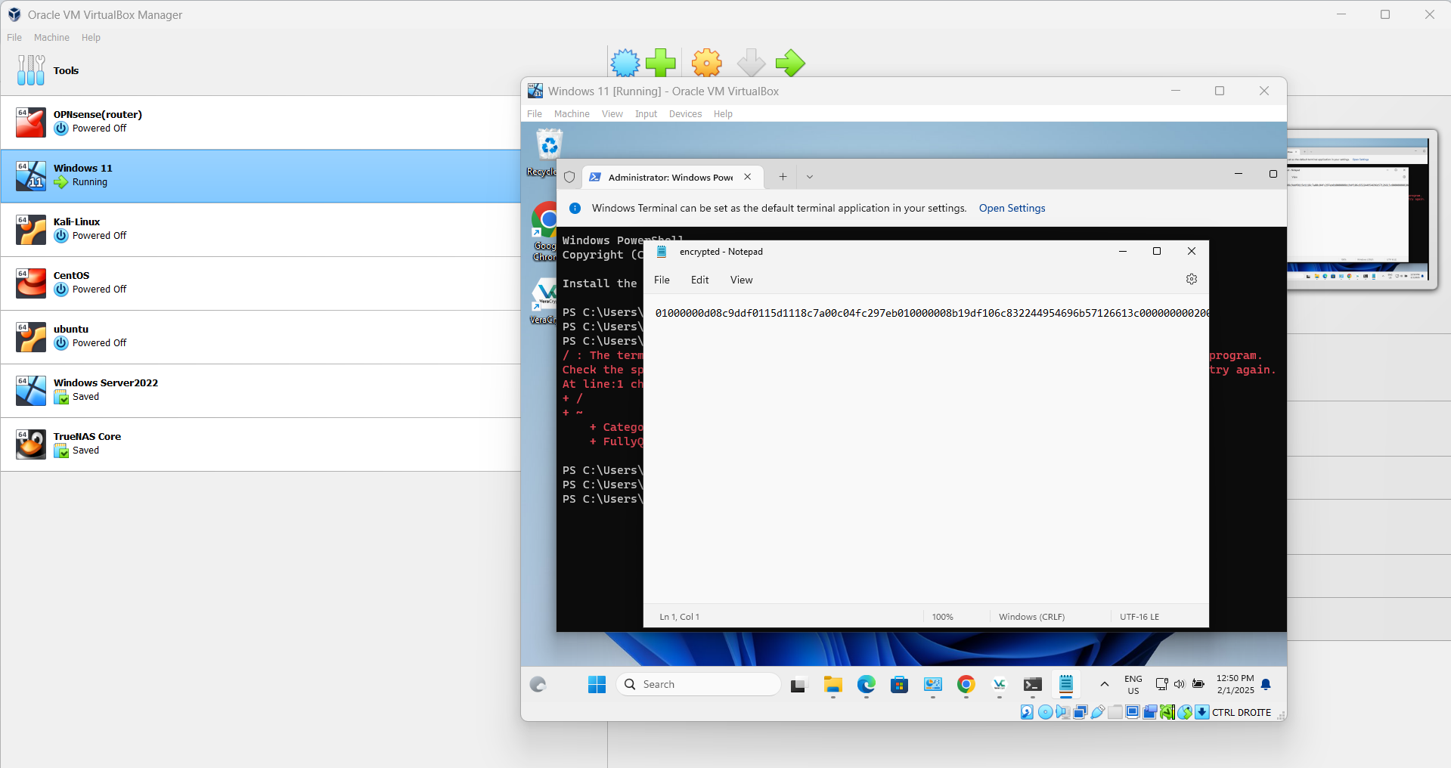

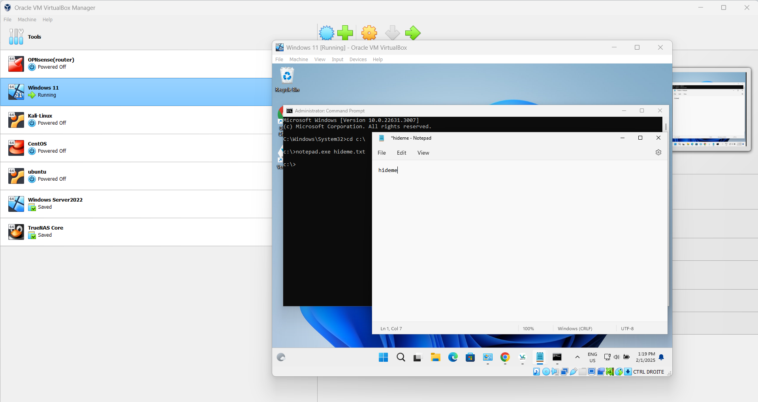

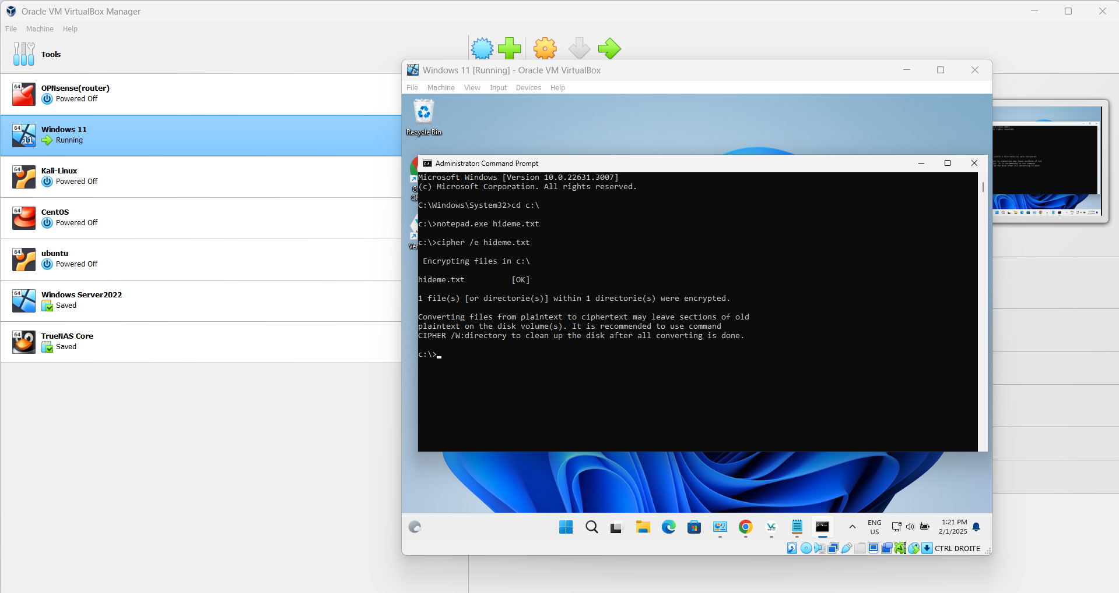

**Encrypting Data with CMD:**

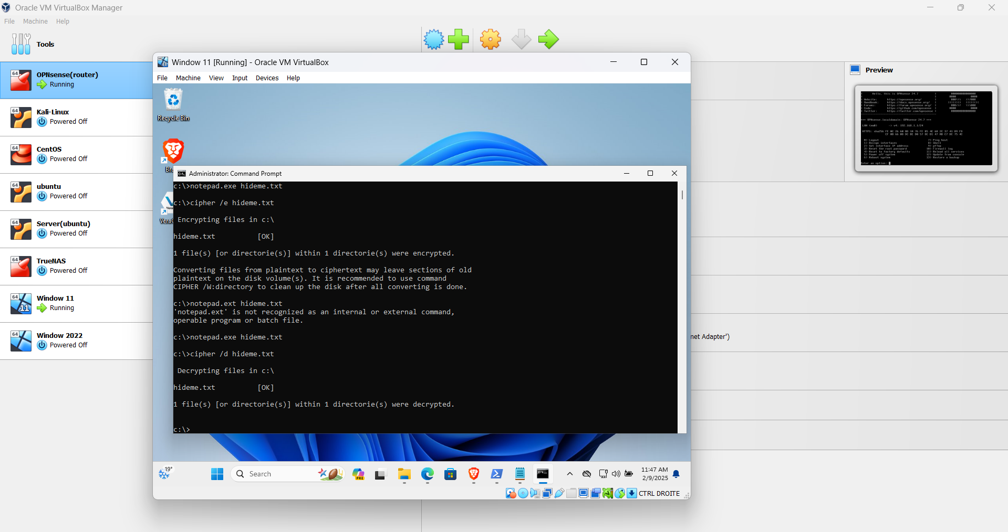

**Part 2: Kali Linux Encryption**

**File and Disk Encryption**

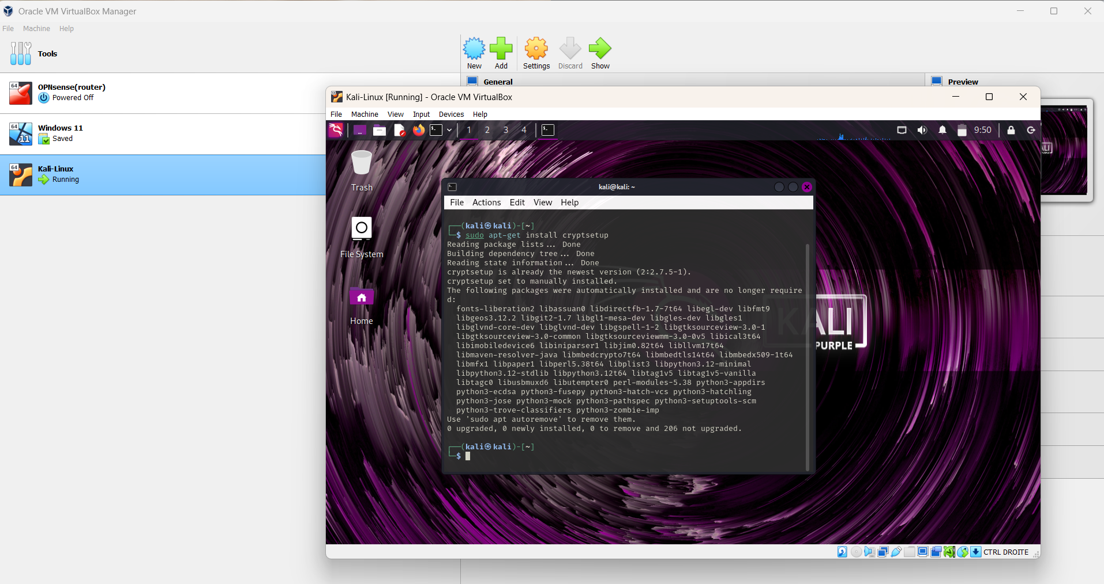

**Set Up the Encrypted Container**

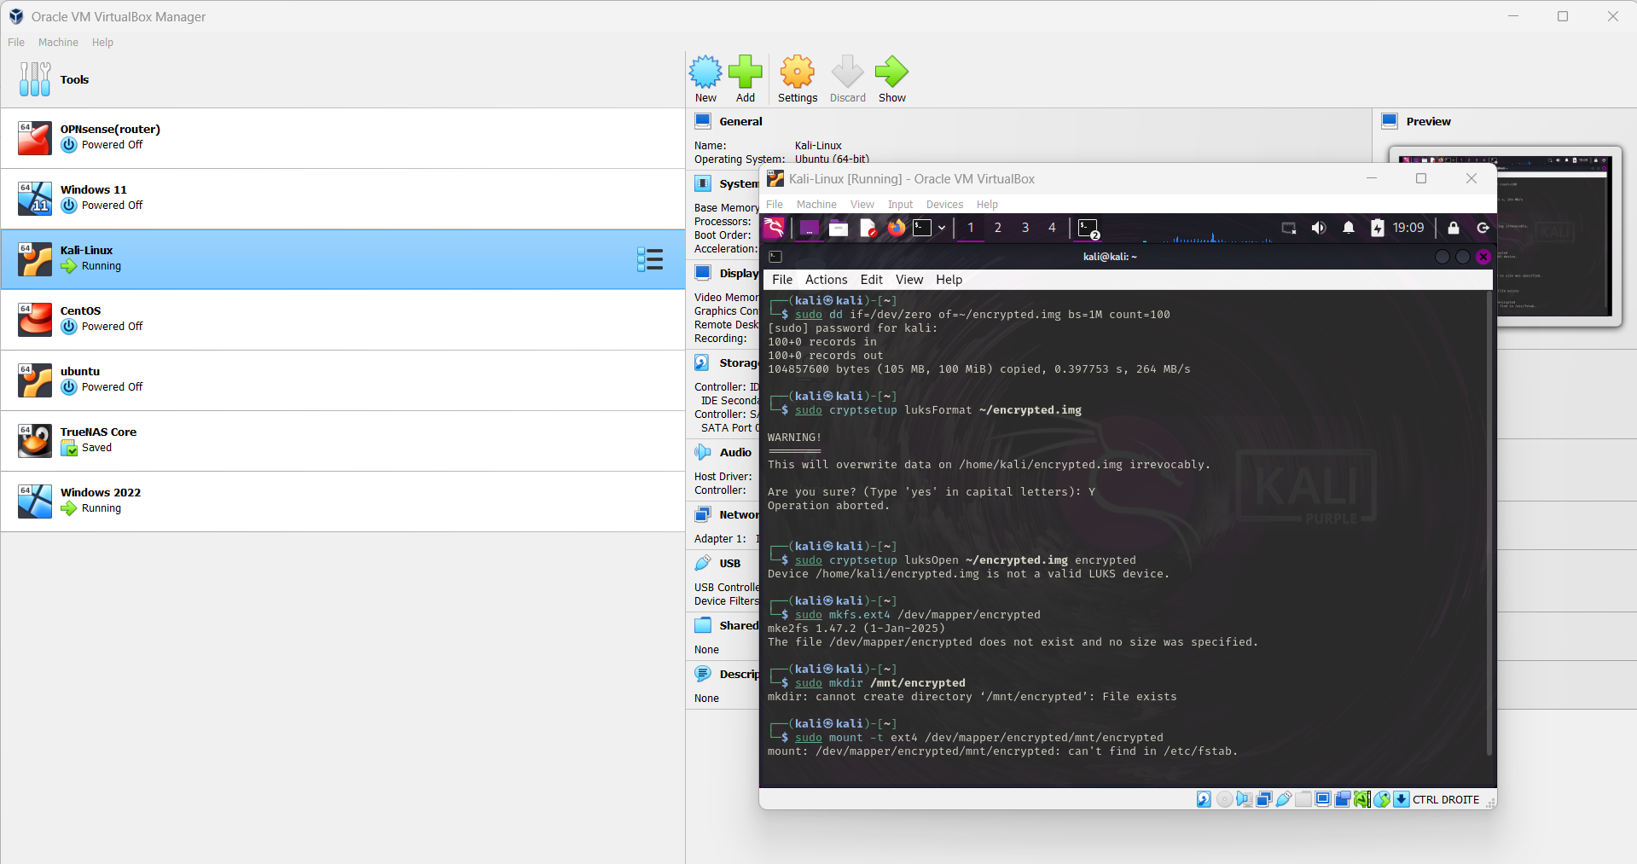

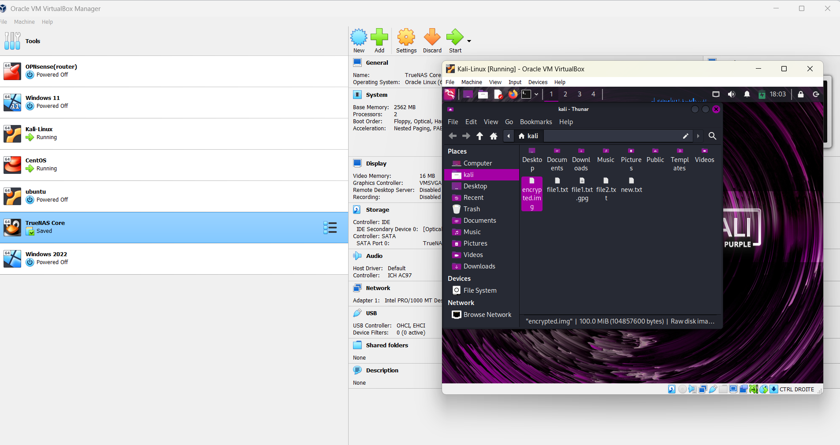

**Encrypting Files with GnuPG**

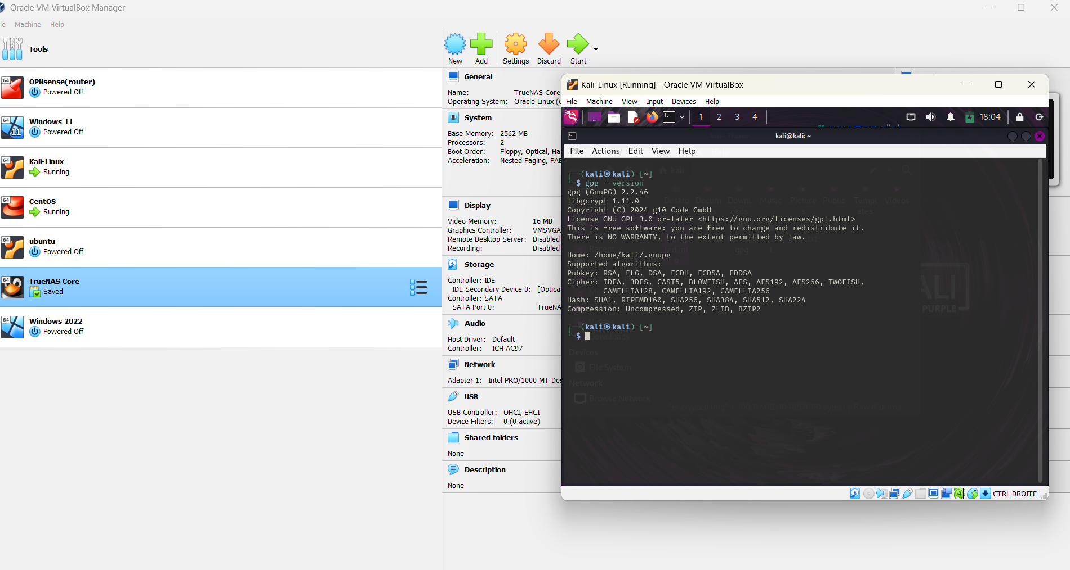

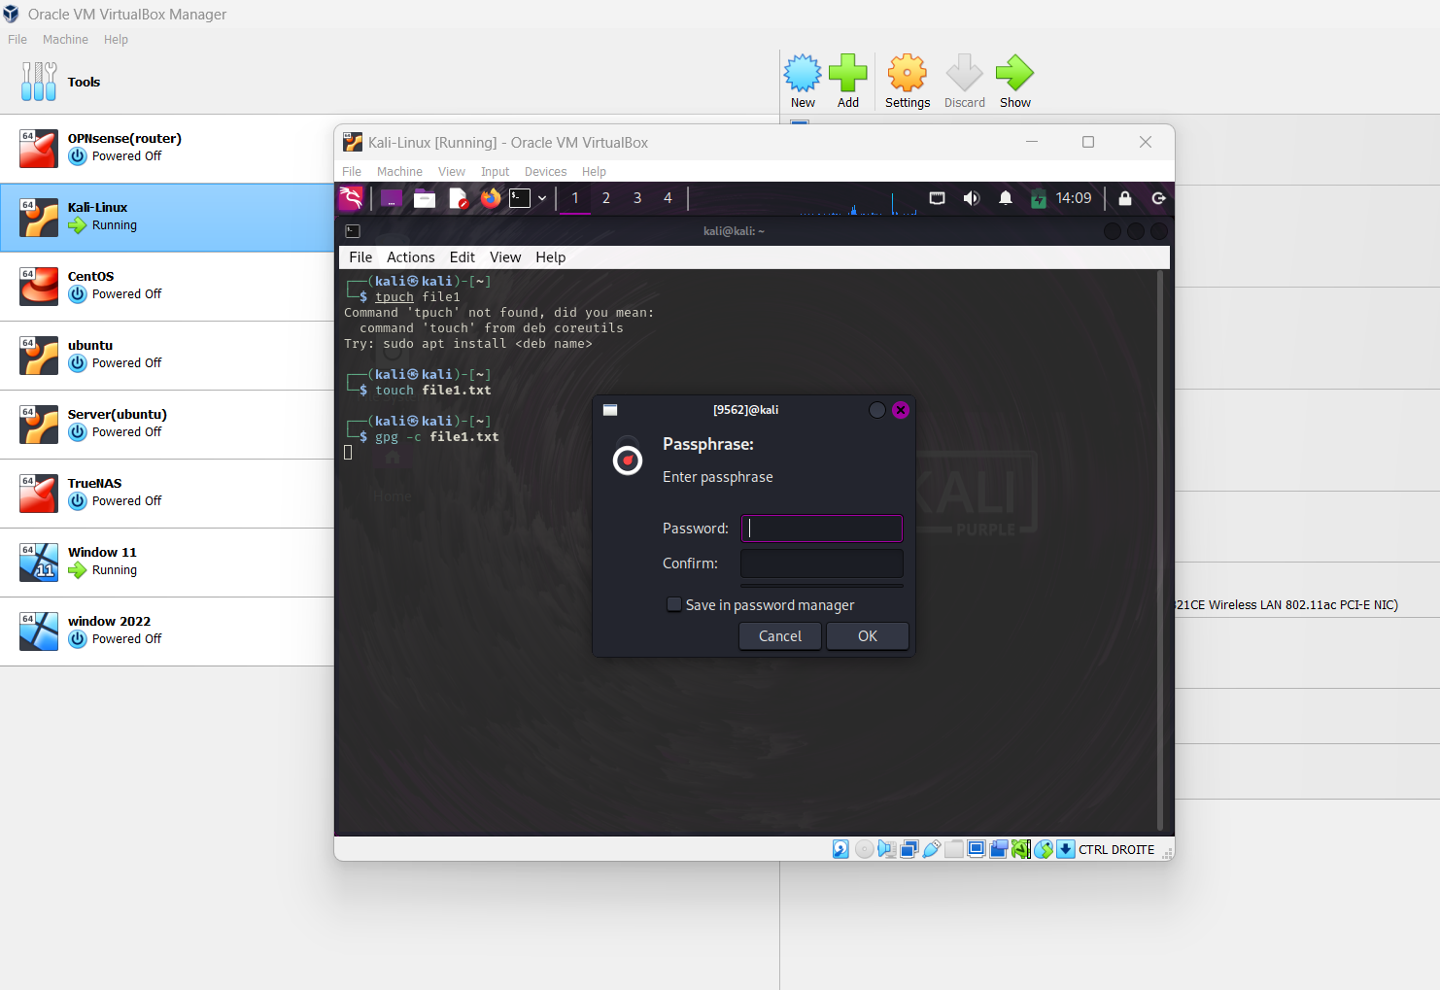

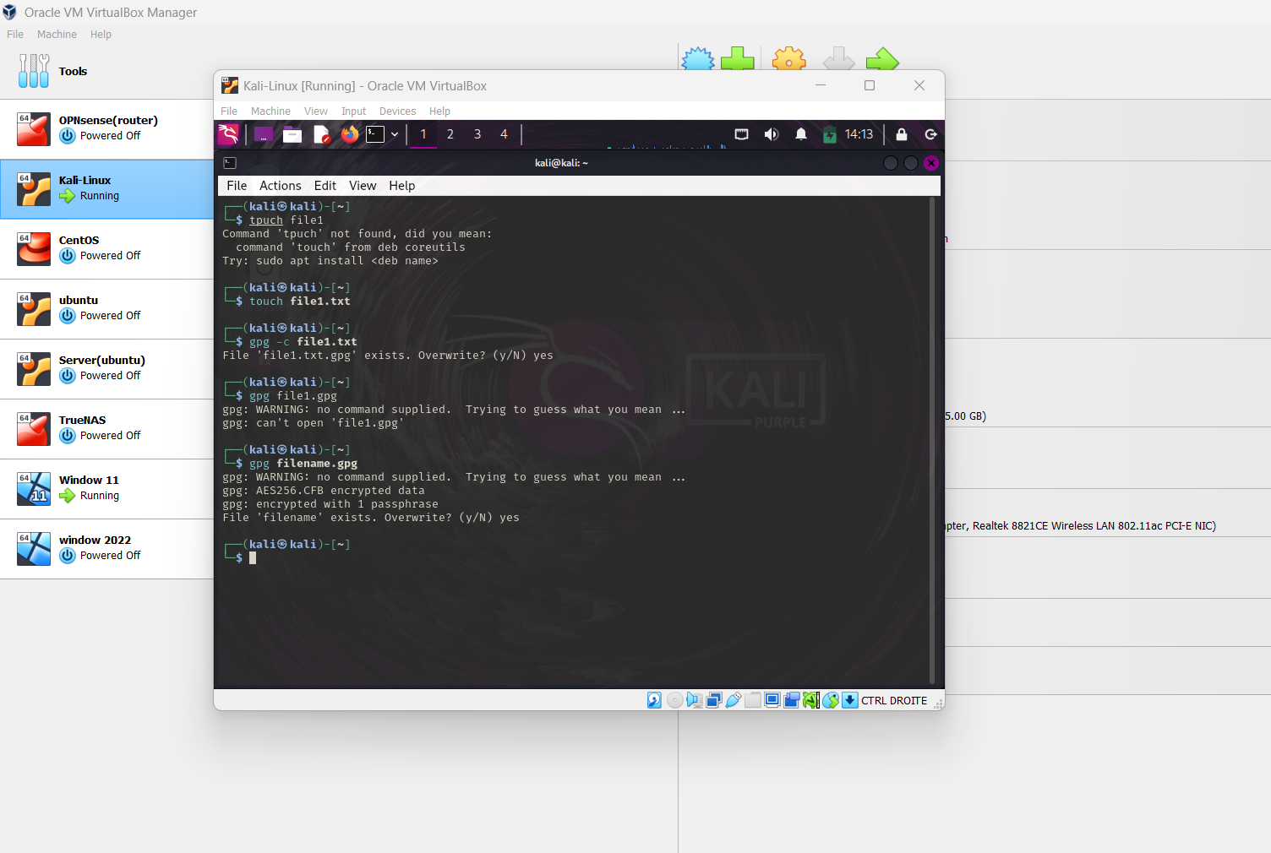

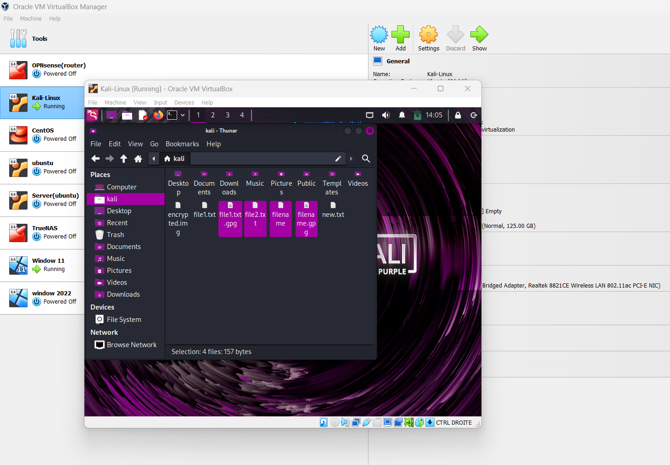

**Part 3: CentOS Encryption**

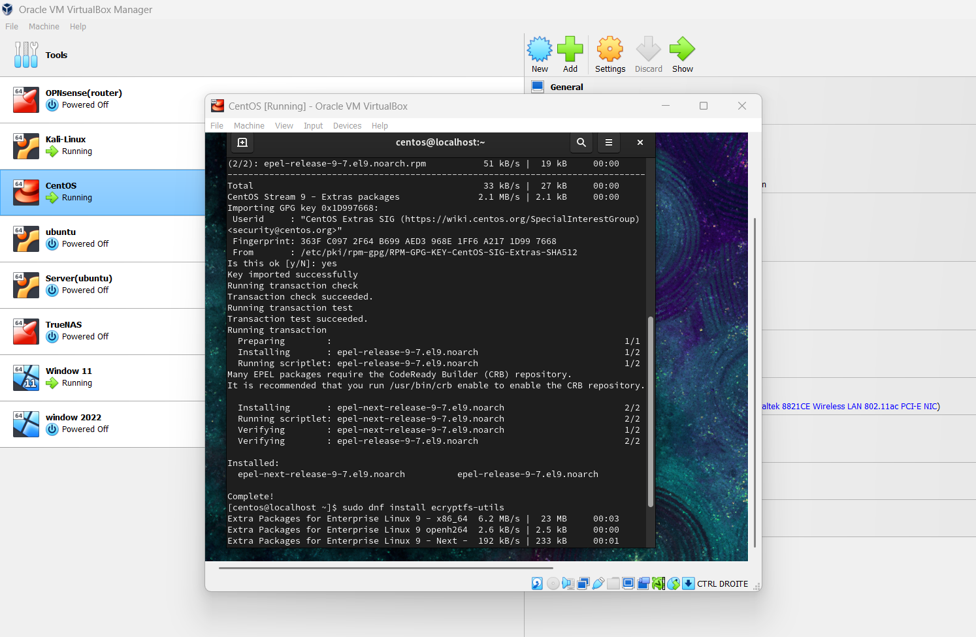

**Step 1: Create an encrypted file container**

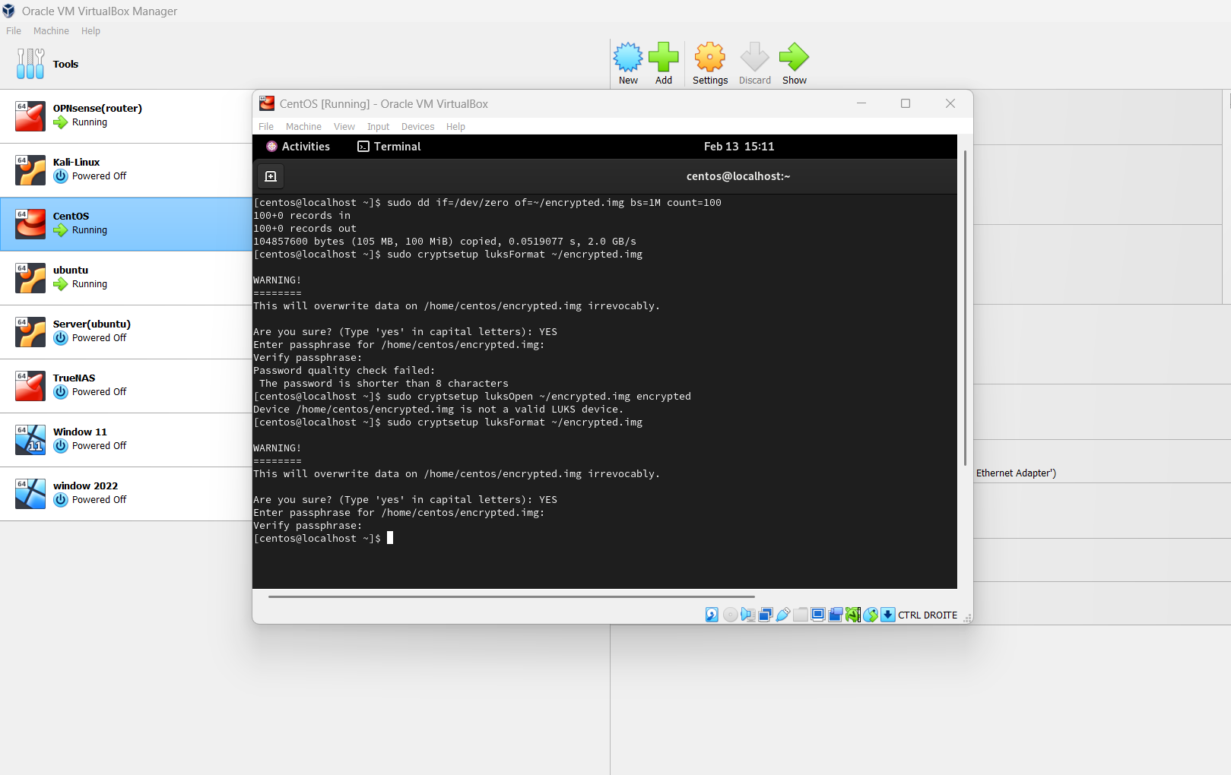

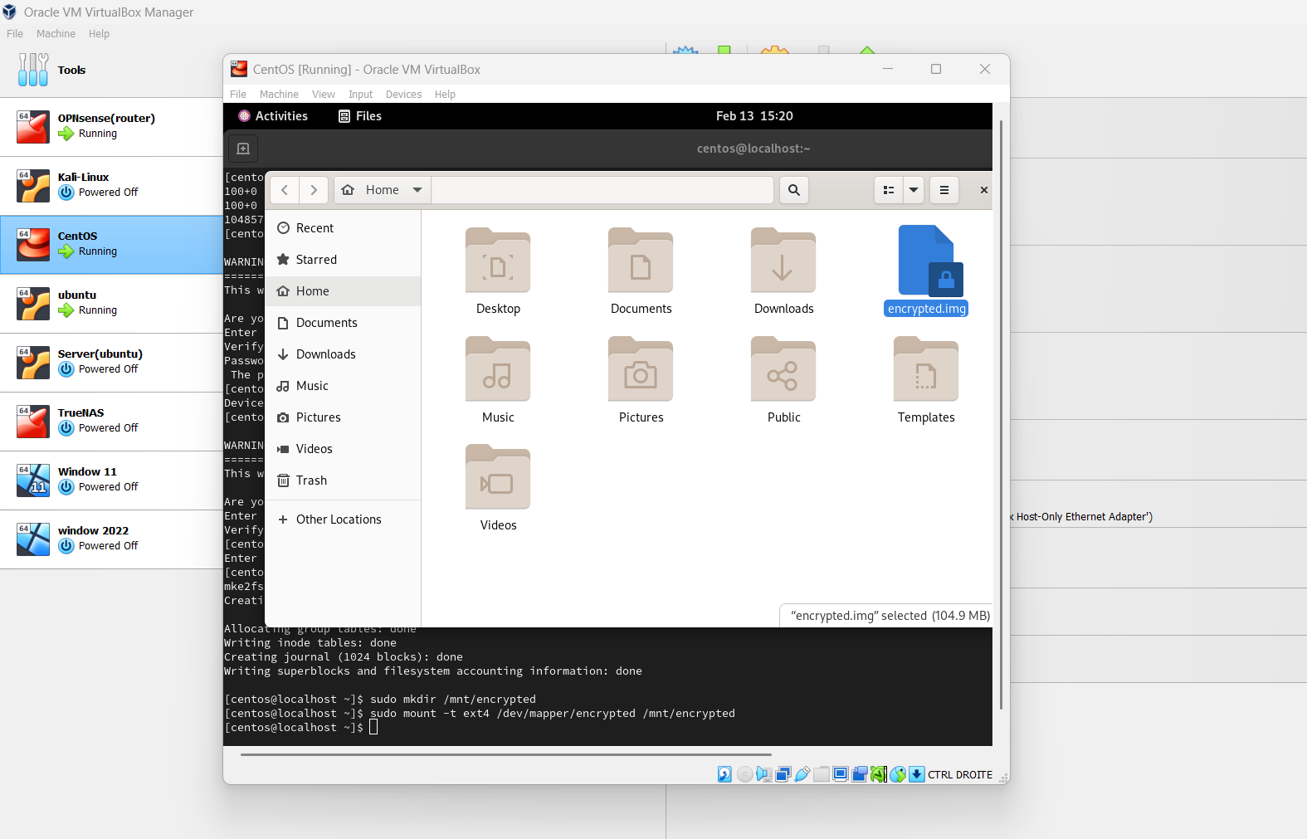

**Step 2: Format the container with ext4**

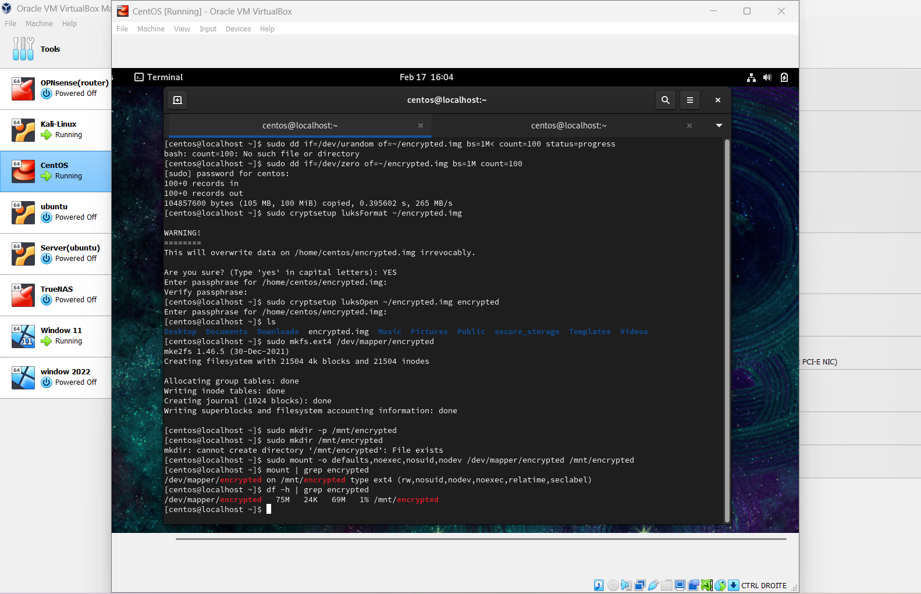

**Step 3: Create a mount point and mount the encrypted container**

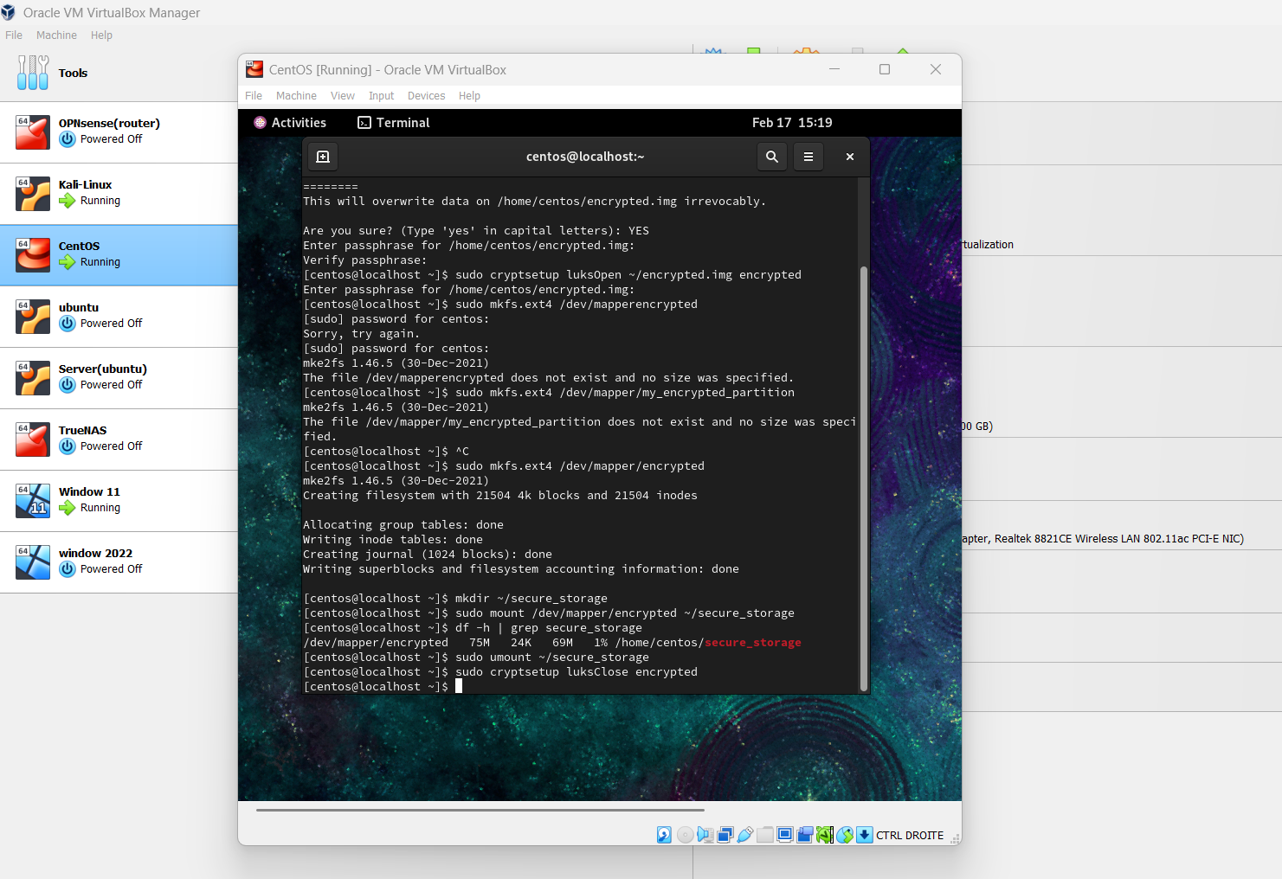

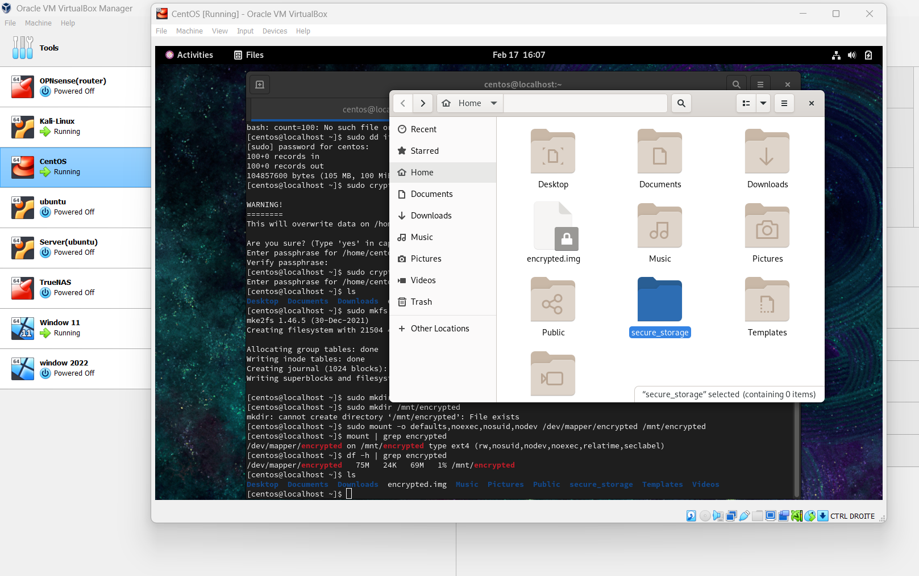

**Part 4: Windows Server 2022 Database Encryption  
SQL Server Encryption**

**Enabling Transparent Data Encryption (TDE):**

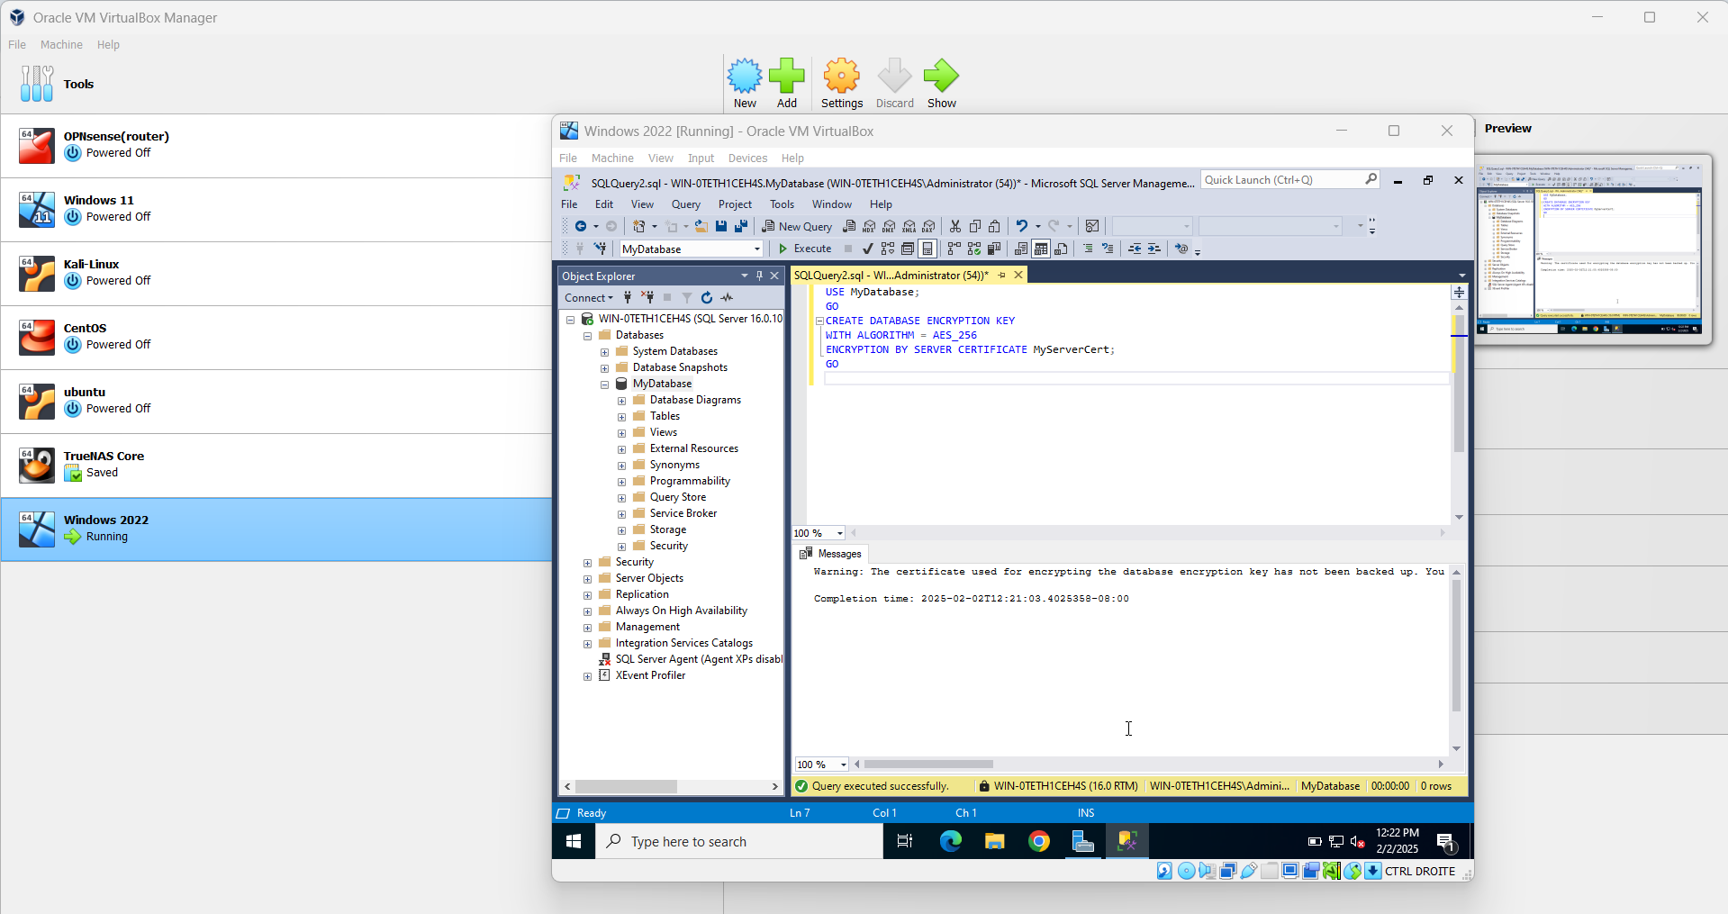

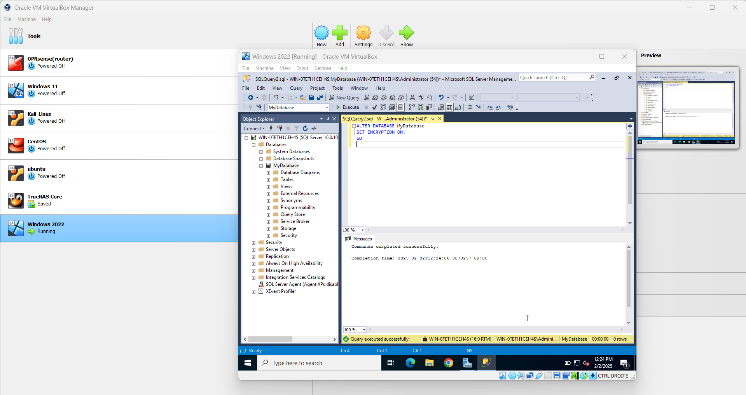

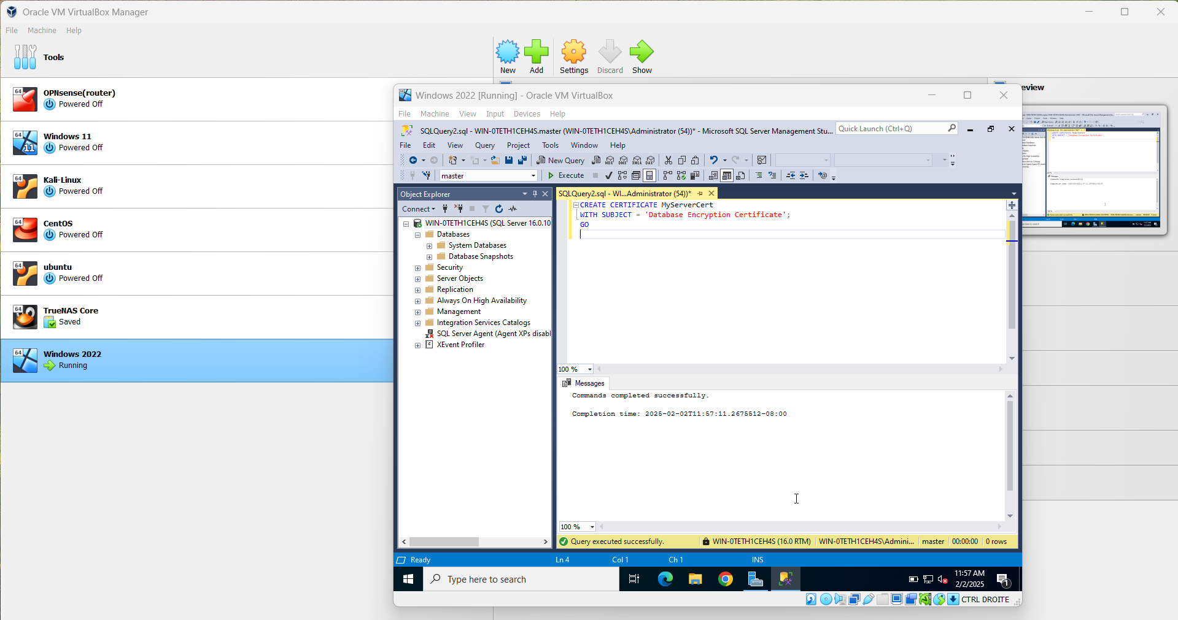

**Backup and Restore Encrypted Databases**

